**Linux Commands Assignment – Explanation**

**Task 1: Basic Linux Commands**

**1. Create project directory and navigate into it**  
We created a new folder for **ProjectX** using **mkdir**, then moved inside it using cd. This sets up a separate workspace for the project.

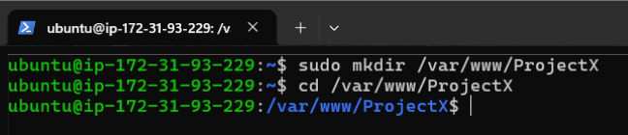

**2. Create files for frontend and backend**  
The touch command creates empty files. We made index.html for the frontend, app.py for the backend, and README.md for project documentation.

**3. Check current working directory**  
pwd shows the full path to the directory we're currently in. It's a quick check to confirm we’re inside the ProjectX folder.



**4. List files with detailed information**  
ls -l lists all files with their permissions, owner, size, and creation time. This helps us understand the access level of each file.

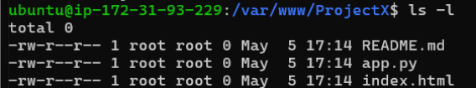

**5. Display system disk usage**  
df -h shows how much disk space is used and available. The -h flag displays it in a readable format like MB or GB.

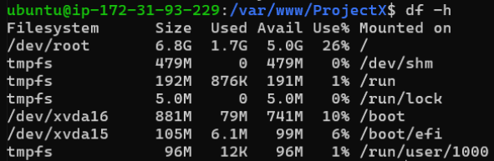

**6. View file content**  
We added text to the README using echo and displayed it with cat. This is a simple way to write and view content in files from the terminal.

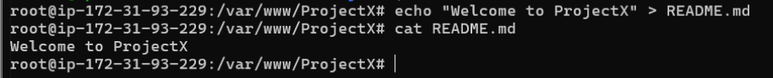

**Task 2: User and Group Permission Management**

**1. Create a group and users**  
We created a developer group **devteam** and added two users (**bhatti** and **malik**) to it. This allows them to work together with shared access.

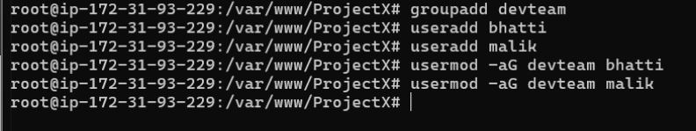

**2. Assign group ownership of the project**  
chgrp -R devteam /var/www/ProjectX assigns group ownership of the entire project folder to devteam, so group members can manage it.

**3. Set directory permissions**  
Using chmod -R 770, we gave read/write access to the owner and group, while blocking access for others. This improves security.

**4. Verify permissions**  
ls -ld /var/www/ProjectX shows that the folder now has the correct permissions and is owned by the correct group.

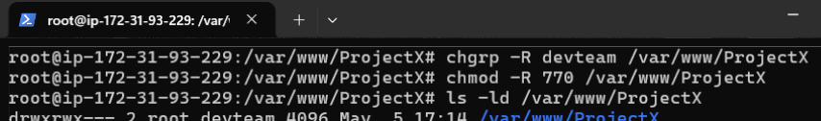

**5. Check user group memberships**  
The groups command confirms that users like bhatti belong to the devteam group, ensuring they have the right access.



**Task 3: Change Ownership**

**1. Change directory ownership to bhatti**  
We used chown -R bhatti:devteam to make bhatti the owner and devteam the group for the project. This allows proper permission control.

**2. Verify ownership**  
ls -l confirms the ownership by showing bhatti and devteam listed next to each file.

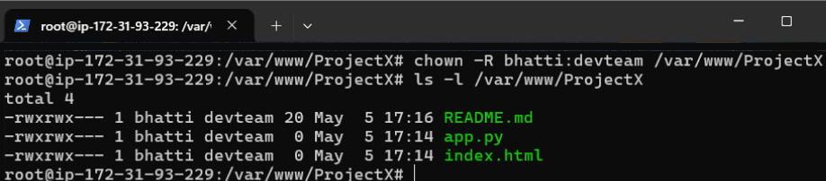

**3. Switch to bhatti and create a file**  
We switched to the bhatti user and created **config.yaml** inside the folder. This verifies that permissions are working as expected.

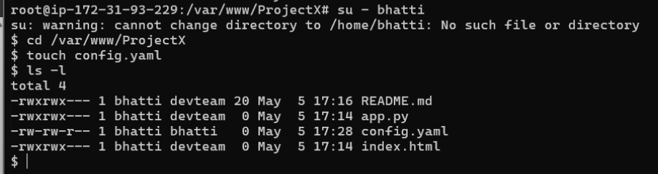

**Task 4: System-Level Commands**

**1. Check system resource usage**  
The top command shows live information about CPU and memory usage. It’s helpful to monitor system performance.

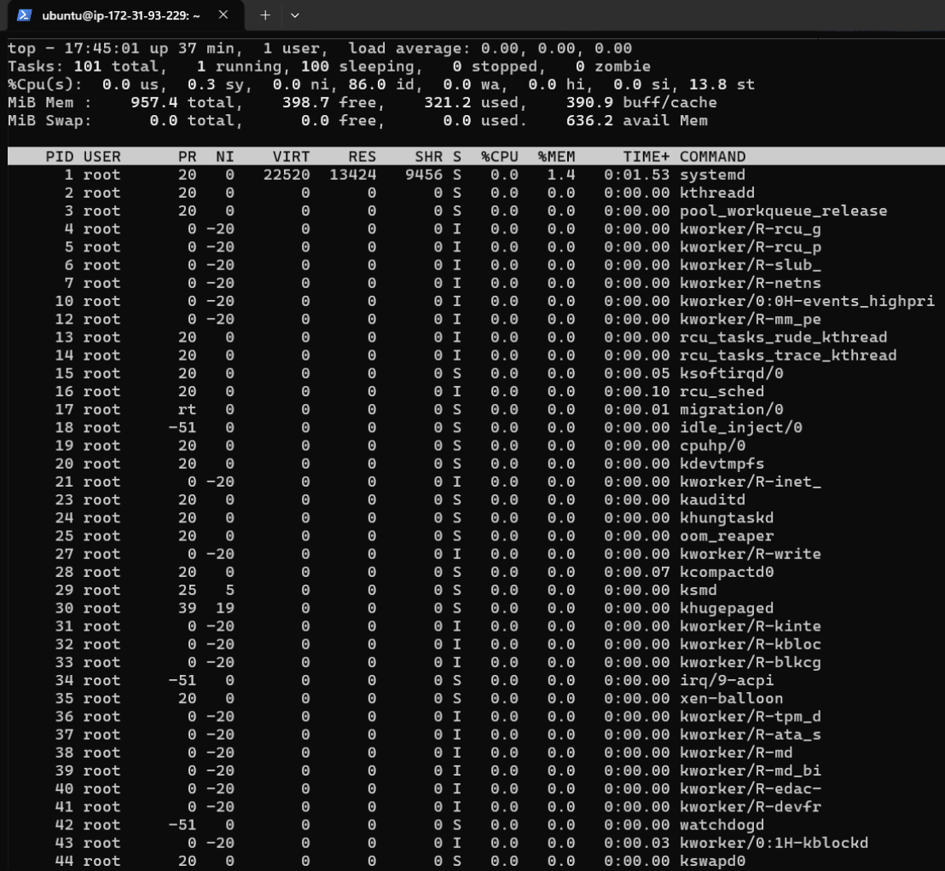

**2. Check running processes for ProjectX**  
Using ps aux | grep ProjectX, we searched for any processes related to our project. This helps in troubleshooting or confirming if services are running.



**3. View system logs**  
tail -n 50 /var/log/syslog displays the last 50 lines of the system log. It's useful for checking errors or system activity.

